

**UNIVERSIDAD SENTIMIENTOS DE LA NACIÓN**

# 

# **Infographic**

**Teoría y Técnicas para Elaborar Proyectos Sociales**

**Presenta:**

**Juan Carlos Esparza Ochoa**

**Facilitadora:**

**María Isabel Beltrán Lerín**

# **Guadalajara, Jal., 14 de septiembre de 2021**

# There, Their, They&#39;re not the same. | Clip art, Free clip art, Notebook paper

what should I do?

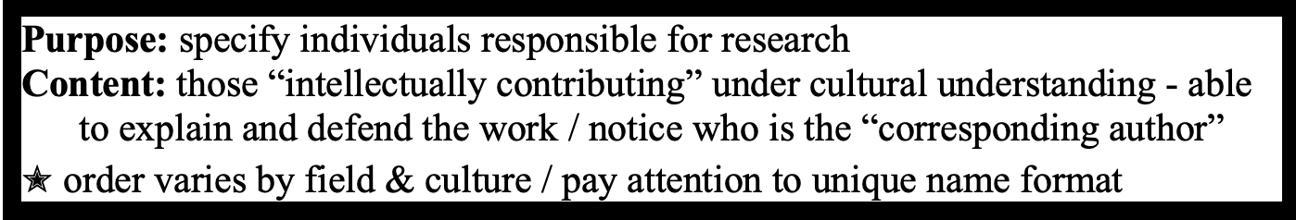 **Title**

 **Authors**

**\*Addresses**

**\*\*Acknowledgments**

|  |
| --- |
| **Abstract** |

**Introduction**



**Methods**

**Results**

|  |
| --- |
| **Tables and Figures** |
| **Table and Figure Legends** |

**Discussion**

**References**

**\*Addresses**

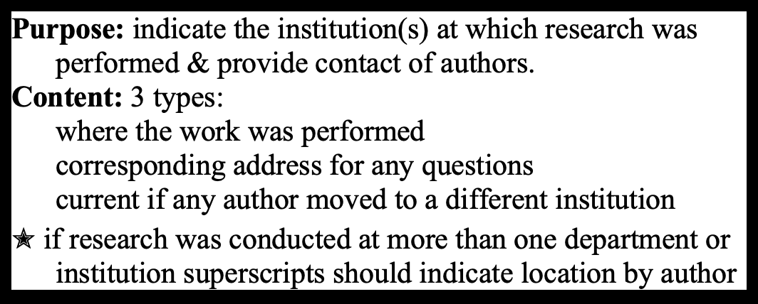 **\*\*Acknowledgments**

|  |
| --- |
| **Purpose:** provide brief summary & interest in reading  **Content:** a mini-paper: intro, methods, results, discussion & final summary  / no abbreviations / intelligible language & avoid misleading  ✭ past tense for work & present for others’ work + general knowledge / 150-300 words |

**Content:** The abstract is written as a mini-paper, i.e., it contains the following information in this order: 1. *introduction*: a few sentences to provide background information on the problem investigated  2. *Methods*: techniques used

3. *Results*: the major results presented in the paper; provide quantitative information when possible.

4. *Discussion*: the authors’ interpretation of the results presented

5. *Final summary*: the major conclusions and “big picture” implications. Note that this is the most important part of the abstract, as researchers will often read this part of the abstract first, to see if the implications of the study are important enough to warrant the reading of the full paper.

In most cases, *abbreviations* are not permitted in an abstract.

Searchable databases and on-line journals now make it relatively easy to obtain titles and abstracts of scientific publications. One of the implications of this is that it can no longer be assumed that only specialists in ones discipline will read the abstract. Indeed, the readership can

ow be assumed to include policy makers, and both advocates and opponents of the research  performed. Thus, authors are advised to take this into account when writing their abstract by (1) making it as intelligible as possible to a general readership, and (2) taking extra care to avoid  stating things that might be misconstrued by readers who are uninformed and/or unsupportive of the type of research described.

**Tense:** The abstract should be written in the past tense for the authors’ work, present tense for general knowledge and other researchers’ work.

**Length:** The number of words permitted in the abstract is usually specified in a journal’s *Instructions to Authors*. Commonly it is 150-300 words.

**Introduction**

**Purpose:** To provide the reader with background on the research described in the paper.

**Content:** The introduction consists primarily of the following types of information, generally provided  in this order:

1. *Why the study was undertaken*: What gap in the knowledge of the field were the authors trying to fill by undertaking this study? What problem were the authors trying to address?

2. *The nature of the work performed*: The variables that were investigated and the methods that were used.

3. *The state of the problem at the end of the study*: A brief statement of the major findings presented in the paper, and implications of the study  for example, how the work contributes to “the big picture,” questions left unanswered, new questions that have emerged.

Note: whereas the information from #1 and #2 are essential components of an introduction, some individuals believe that the information from #3 is optional. We strongly recommend including  this information as it helps the reader to evaluate more accurately what they are reading in the sections that follow. This point helps to highlight one of the major distinctions between scientific writing and many other types of prose writing  *in scientific writing everything is done to avoid mystery or suspense*.

It is essential that the Introduction should provide a brief but scholarly review of the relevant literature with appropriate references (see “References,” below). Authors should neither unduly inflate their contributions nor obscure controversy by ignoring papers that have already been published.

Abbreviations should generally not be used in the title or abstract, and only sparingly in other parts of the manuscript. A rule of thumb is not to use an abbreviation unless the word is used at least 10 times or is best recognized in its abbreviated form. When an abbreviation is to be employed, it should be defined the first time it is used and then always used thereafter. For example,

*The questionnaire was given to 100 employees of the Environmental*

*Protection Agency (EPA), as well as 50 former EPA employees.*

4

BA Fischer & MJ Zigmond survival@pitt.edu 

Most journals will provide a list of abbreviations that do not need to be defined because they are commonly used. Consult the *Instructions for Authors*.

**Tense:** What the authors did/found is in the past tense; everything else is in the present tense. **Length:** Generally not more than 500 words.

**Methods**

**Purpose:** The methods section serves two functions: (1) to enable readers to evaluate the work performed (e.g., did the authors use the most appropriate and accurate techniques for their work?), and (2) to permit readers to replicate the study if they desire to do so.

**Content:** All aspects of the methodology used in the study must be described thoroughly enough so that scientists working in that field would be able to replicate the work. This includes both what was used as well as what was done. Thus, sometimes this section is referred to as “*Methods and Materials*.”

If the method has already been published in the scientific literature (whether or not it was written  by the same authors), readers should be referred to the original description for the details of the method. However, it is important to include enough information so that readers are able to  evaluate the work being presented without having to refer to another publication. This means specifying the critical variables for that type of work, for example, how long the samples were incubated, how many minutes subjects were allowed to work on a task, or what strain of laboratory rats were used. In addition, it is essential to indicate any deviations from the method cited.

Often the company (including city and state) that manufactures a particular reagent is specified  to reduce any ambiguity about what was used; likewise, the model number for a piece of equipment is often indicated.

**Tense:** Past tense.

**Style:** If several different procedures are described, it is preferable to subdivide the methods section via the use of headings. This enables readers to refer quickly back to a specific method.

**Results**

**Purpose:** To provide the data collected.

**Content:** The contents of the Results section depend on type of article:

In ***full-length research articles***, the more common type of article, only data - what was observed  - is included in this section. Interpretations should be reserved for the discussion section. The idea behind this format is to “let the data speak for themselves.” However, some authors like to include some introductory or transition material to help the flow of this section.

5

BA Fischer & MJ Zigmond

survival@pitt.edu

In ***short research articles*** (sometimes called “short” or “brief” communications), results and discussion (interpretation) are sometimes mixed. Refer to the journals’ *Instructions to Authors* for guidance.

**Tense:** Authors’ results should be in past tense, and general statements in present tense.

**Style:** If the results of several different experiments are described, it is preferable to subdivide this section via the use of headings.

**Length:** This usually is the shortest section of a manuscript.

**Discussion**

**Purpose:** To provide the reader with a plausible interpretation of the data reported and to relate these findings to what other investigators have found.

**Content:** The section provides the following information, generally in this order:

1. *Summary of conclusions*: what the authors conclude from their data, for example,  relationships between variables, trends, etc.

2. *Relation to other results*: the relation of these findings to previous work, e.g. “supports the findings of Alvarez et al., (1994)” or “is contrast to …”

3. *Aberrant results:* any abnormalities or exceptions inherent in the data or in relation to with respect to the scientific literature, and if possible, explanations for these aberrations. (Note: item #3 and #4 may be intermixed.)

4. *Implications:* theoretical or practical implications of the work, i.e., “the big picture” 5. *Grand summary:* a summary of the results and conclusions reported in the paper **Tense:** Current knowledge is stated in present tense, the author’s work is stated in past tense.

**Style:** If headings were used in the results section, it is very convenient for the reader if the relevant portion of the discussion is presented under the same headings.

**Length:** generally, up to 1500 words.

**Acknowledgments**

**Purpose:** To recognize and thank those individuals and organizations whose contributions to the work  presented should be acknowledged but are not extensive enough to merit authorship.

**Content:** When applicable, the following information is presented in this order:

6

BA Fischer & MJ Zigmond survival@pitt.edu 

1. Individuals other than authors who made a significant contribution to the research by donating important reagents or materials, collecting data, providing extensive advice on drafts of the manuscript, etc. Typically, the nature of the contribution is noted; for example

*The authors thank Dr. Marcia Jones for providing the genetically*

*modified mice used in these studies, and Mr. David Wendall for his*

*assistance in analyzing the tissue samples.*

2. If the work has been presented at a conference, then this is often noted. For example,

*Portions of this work were presented at the 25th Annual Society for*

*Neuroscience Meeting, November 11-16, 1996, San Diego, CA.*

3. Organizations that funded the research. The general format for this information is *This work was supported by U.S. Public Health Service Grant MH43947.*

Note that it is ***essential*** to get permission from any individual whose help is acknowledged. Also, many scientific societies and journals are indicating that it is essential to disclose any financial support that has been provided for the work.

**Length:** Limit to significant contributors.

**References**

**Purpose:** To provide the full citation for article referenced in the text.

**Content:** A complete reference includes all of the authors’ names, the title of the article, the journal name, the volume number, page numbers, and the year of publication.

**Style**: A wide range of styles is used for citing references in the text and bibliography. Check the journal’s *Instructions to Authors* for information about the content and formatting of references.

Within the text, articles are cited by providing the author and year of the article (e.g., Fischer and  Zigmond, 1996). When there are more than two authors, the first author is provided together with *e. al.* (e.g., Fischer et al..., 1996). If more than one reference is cited for a given point, they are usually listed in chronological order (e.g., Zigmond and Fischer, 1995; Fischer et al., 1996). If there is any ambiguity, a letter can be added to the year of publication (e.g., Fischer et al., 1995a; 1995b).

At the end of the paper a list of references, or bibliography, is provided. This list must be limited to the references cited within the text and most often is provided in alphabetical order.

In some cases citations appear in the text as numbers, usually a superscript, which then refer to a particular item in the reference list.

It is the obligation of the authors to provide a scholarly listing of the primary references of relevance to the paper. Authors are obliged to do a thorough review of the key areas of the scientific literature as part this process. In general, original *research* articles rather than *review*

7

BA Fischer & MJ Zigmond survival@pitt.edu 

articles should be cited, and the research articles should be the earliest ones that made the particular finding.

It is essential that authors check each reference that they cite. Simply copying a reference from the bibliography of a published paper is inadequate since errors in referencing are very common.  In checking a reference, authors must not only make sure that the citation is accurate but also that the text actually supports the point for which it being used as a reference.

References that are not readily available or are in a language not understood by the author present a particular challenge. In the former case, most libraries provide a service that enables authors to obtain papers from a wide range of other libraries. An alternative that is sometimes available is to contact directly the author of the article in question and request a copy.

Articles in foreign languages sometimes provide enough information in their tables and figures to permit an accurate comprehension of their results, even if the language itself is not understood. In this regard it is helpful that a number of scientific terms are the same in English as in many other languages. Alternatively, it usually is possible to have an article translated by a local service.

If a reference cannot be checked by the author, the only alternative to not citing it is to cite it as a secondary reference (e.g., Hooke, 1665, as cited in Fischer, 1995).

If citations are needed for more than one point in a sentence, it is helpful for the reader if the citations appear throughout the sentence, rather than as a collection at the end. For example,

*Previous studies have shown that this compound can exist in a solid (Wang and Beauford, 1993), liquid (Jones et al., 1992), or gaseous (Diaz, 1995) state.*

**Length:** Ideally, a paper will list all the references necessary to document each point that is made by the authors. In practical terms, however, most journals will impose a limit in order to conserve space. A rule of thumb is no more than 6 references for a particular point and no more than 100 references per paper.

**Tables and Figures**

**Purpose:** To report data that are too numerous or complicated to be described adequately in the text; to reveal trends or patterns in the data.

**Content:** Tables; possible figures include graphs (bar, line, scatter), diagrams, cartoons (i.e., chemical structures or mechanisms), and photographs.

**Style:** Figures are usually in black and white. Color is extremely expensive to publish, and should only  be used when it provides unique information. (Note: For further details see “Construction of Tables and Figures,” which will be posted soon.)

**Number:** Limit the number of tables and figures to those that provide essential information that could  not adequately be presented in text.

8

BA Fischer & MJ Zigmond

survival@pitt.edu

**Table and Figure Legends**

**Purpose:** To provide a knowledgeable reader with the information required for understanding the table or figure.

**Content:** The composition of a legend depends on the item it refers to. It should provide information regarding the conditions of the experiment, but not give a summary or interpretation of the results. In addition, statistical information is often provided. This may include

1. The number of times an experiment was performed or a condition was tested.

2. What the values in the table or figure represent, for example *mean* ± *S.E.M.* (standard error of the mean)

3. The statistical test used in analyzing the data

4. Whether the test was “one-tailed” or “two-tailed” (if relevant)

5. The *p* value that was used in determining significance

6. If an asterisk or other mark is used in the table or graph to denote statistically significant results, then this mark should be defined.

For example, the statistics portion of a figure legend might look like this,

*n=5 for each condition. Values represent mean* ± *S.E.M. Data were analyzed*

*using a one-tailed Student’s t-test. * denotes significance, p* < *0.05.*

**Tense:** Past tense.

**Style:** Each table and figure should be understandable on its own, without reference to the text.

Within a manuscript, the placement of the legend varies depending on whether it refers to a table or figure:

***Table***: The title, table, and legend should appear on the same page, in the order listed.

***Figure***: Each figure should appear on a separate page. The numbered legends are listed one after another (i.e., several to a page). The title for a figure comprises the first sentence in the figure legend.

9

BA Fischer & MJ Zigmond survival@pitt.edu 

**Bibliography of Resources**

*There are many useful books about writing research articles. We have*

*listed below a selection of the best, those that we believe deserve*

*a place in every technical writer’s library.*

1. Briscoe, M.H. *Preparing Scientific Illustrations: A Guide to Better Posters, Presentations, and  Publications, 2nd Edition.* New York: Springer, 1996.

We cannot overstate the usefulness of this book. If you have questions about constructing tables and figures, the answer is probably in here.

2. Council of Biology Editors. *Scientific Style and Format: The CBE Manual for Authors, Editors, and Publishers, 6th Edition.* NY: Cambridge University Press, 1994.

Excellent reference text.

3. Woodford FP (1999) *How to Teach Scientific Communication.* Reston, VA: Council of Biology Editors

An outstanding guide to how to teach writing. Includes a number of "before and after" examples. 4. Day, R. A. *How to Write and Publish a Scientific Paper, 5thEdition.* Phoenix: Oryx Press, 1998.

There are a great many books on the subject; this is the best — wise and witty, takes you from creating the title to checking the galley proofs. Robert Day has been our teacher and the inspiration  for these workshops.

 BA Fischer & MJ Zigmond

www.survival.pitt.edu

survival@pitt.edu

July 9, 2004 (rev)

10

BA Fischer & MJ Zigmond survival@pitt.edu